Thesis: Samara Seed Kinematics and Dynamics

Statistical Analysis of Samara Morphology and Transition Time

Shashwat Sparsh

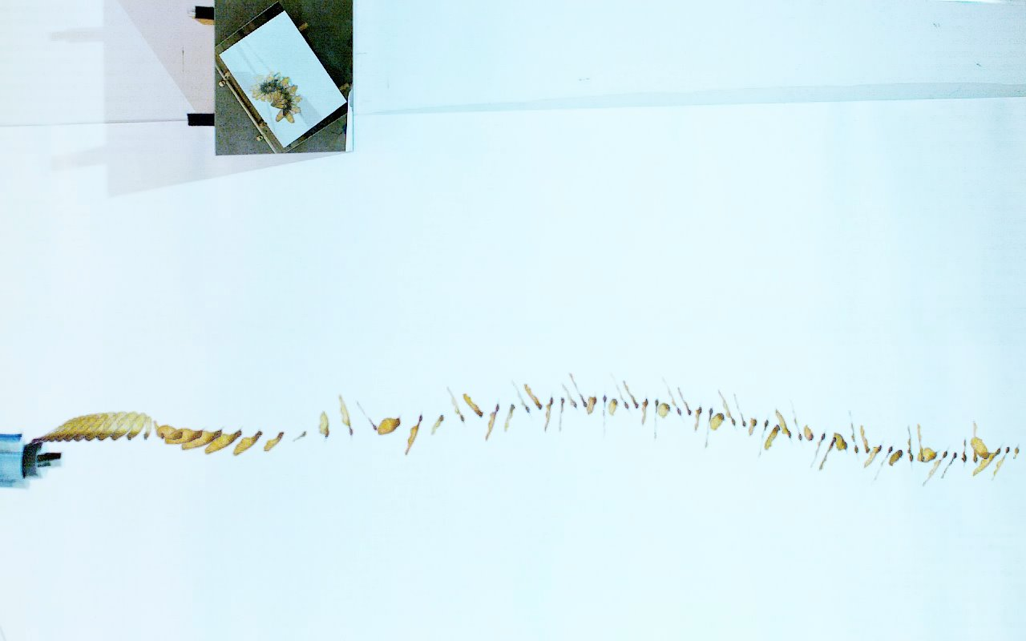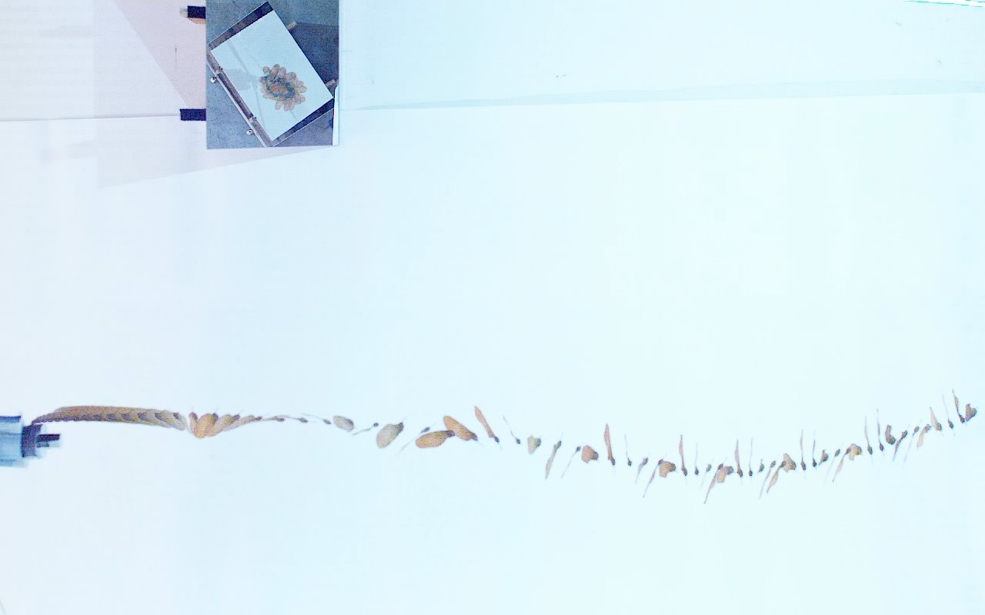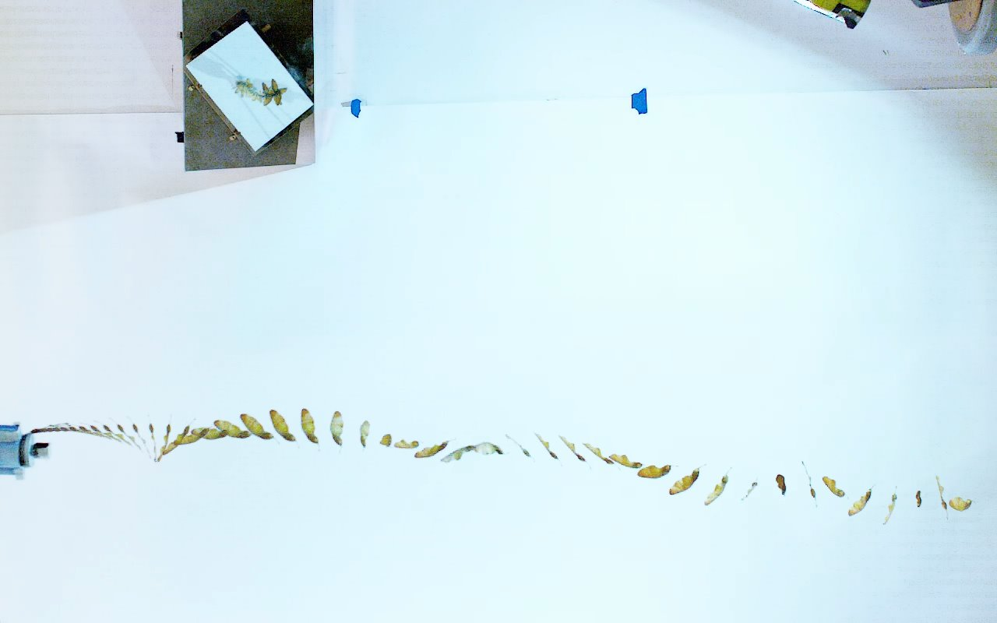

Table of Contents

Background 3

Morphological Distributions 4

Transition Time Distributions 6

Independent 2 Sample T-Test Results 7

Hypothesis Test 8

Mass Based Samples 8

Wing-Loading Based Samples 8

Summary 9

References 10

Appendix A: Mass Data 12

Appendix B: Wing Loading Data 15

Appendix C: Regression Lines 18

Figure 1: Samara Seed Stages, Varshney [23] 3

Figure 2: Samara Seed Geometry, Jung [9] 3

Figure 3: Trajectory for Seed 3, Fast Transition CaseCharts 4

Figure 4: Mass Distribution 4

Figure 5: Transition-Time Distribution **Error! Bookmark not defined.**

Figure 6: Wing-Loading Distribution **Error! Bookmark not defined.**

Figure 7: Transition Time and Mass Distribution 6

Figure 8: Transition Time and Wing-Loading Distribution 7

Table 1: Mass Descriptive Statistics 4

Table 2: Wing-Loading Descriptive Statistics 5

Table 3: Transition-Time Descriptive Statistics 5

Table 4: Mass Based T-Test 7

Table 5: Wing-Loading Based T-Test 8

# A diagram of a plant Description automatically generatedBackground

Samara seeds are a common topic of research in the field of aerodynamics and evolutionary sciences due to their tendency to auto-rotate as they fall. As a result of this characteristic nature, they are colloquially referred to as helicopter plants. Biological studies on these seeds predominantly focus on mapping out statistical distributions of their morphology such as looking at span, chord, and mass (Figure 2)[1]. Aerodynamic studies typically focus on evaluating the kinematic and dynamic responses of samara during the auto-rotation stage. Samara seed descent (Figure 1)[2] can be classified into three separate stages, Free-Fall, Transition, and Steady-State. The free-fall stage occurs when the seed is initially following and behaving like a typical projectile. The transition stage takes place between the free-fall and steady-state where the seed begins to spin but has not entered steady-state autorotation. The final stage is steady-state autorotation where the seed has begun to spin steadily and is generating thrust slowing its descent.

The goal of this study is to identify whether mass or wing-loading is a better predictor of transition-time, a question posed by this thesis. This study analyzes a sample of 84 seeds collected and tested using a high-speed imaging rig. This set-up allowed for the collection of trajectory data which allows for the extraction for transition time which occurs once the “zNorm” motion becomes periodic (Figure 3). A distribution of the various properties can be found in the morphology subsection under charts.

Figure : Samara Seed Stages, Varshney [23]

This statistical analysis is an independent two sample t-test assuming unequal variance on the 84 seed sample. This sample was split into two based on mass (g) and wing loading (N/m2) and two individual tests were conducted to analyze the independence of the relationships between transition-time and these parameters.

Figure : Samara Seed Geometry, Jung [9]

Figure 3: Trajectory for Seed 3, Fast Transition Case

## Morphological and Time Distributions

Figure : Mass Distribution

|  |  |
| --- | --- |
| *Mass [g]* | |
|  |  |
| Mean | 0.45952381 |
| Standard Error | 0.014283324 |
| Median | 0.45 |
| Mode | 0.4 |
| Standard Deviation | 0.130908823 |
| Sample Variance | 0.01713712 |
| Kurtosis | 0.001158372 |
| Skewness | 0.06760225 |
| Range | 0.7 |
| Minimum | 0.1 |
| Maximum | 0.8 |
| Sum | 38.6 |
| Count | 84 |

Table : Mass Descriptive Statistics

|  |  |
| --- | --- |
| *Loading: mg/A [kg/m^2]* | |
|  |  |
| Mean | 4.328611115 |
| Standard Error | 0.126547236 |
| Median | 4.198695655 |
| Mode | #N/A |
| Standard Deviation | 1.159824575 |
| Sample Variance | 1.345193046 |
| Kurtosis | 0.847317471 |
| Skewness | 0.576620521 |
| Range | 6.193674417 |
| Minimum | 1.361055837 |
| Maximum | 7.554730254 |
| Sum | 363.6033337 |
| Count | 84 |

Table : Wing-Loading Descriptive Statistics

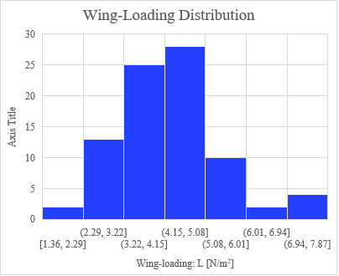

Figure : Wing-Loading Distribution

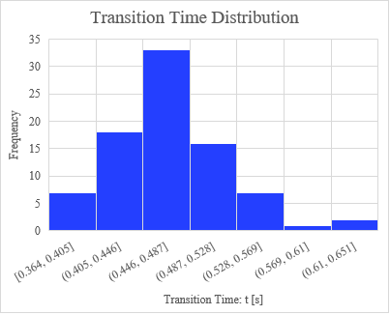

Figure : Transition-Time Distribution

|  |  |
| --- | --- |
| *Transition Time: t [s]* | |
|  |  |
| Mean | 0.471922619 |
| Standard Error | 0.005603096 |
| Median | 0.47 |
| Mode | 0.463 |
| Standard Deviation | 0.051353224 |
| Sample Variance | 0.002637154 |
| Kurtosis | 0.946739536 |
| Skewness | 0.510069604 |
| Range | 0.26 |
| Minimum | 0.364 |
| Maximum | 0.624 |
| Sum | 39.6415 |
| Count | 84 |

Table : Transition-Time Descriptive Statistics

It should be noted that the mass of these seeds appears to be slightly negatively skewed with an average of .460 grams. The mass values being discretized by step-sizes of 0.1 grams is the result of a limitation of accuracy of the weighing scale used in the data gathering process. Wing-loading, a function of both mass *and* area, appears to be moderately positively skewed with an average of 4.33 N/m2. The transition-times for these seeds appear to be moderately positively skewed with an average of .472 seconds. All distributions have a Kurtosis > 1 indicating the higher potential of extreme outliers than a normal distribution.

## Transition Time Distributions

Distributions of the mass and wing-loading measurements with respect to the transition-time were also constructed to illustrate the spread of data.

Regression models poorly characterized the relationship between mass and transition-time. A power-based model of: $y = 0.5072x^{0.0944}$, had a corresponding R2 value of .082. This may in part be due to the mass values being discretized by 0.1 increments.

Regression models also poorly characterized the relationship between wing-loading and transition-time. A power-based model of: $y = 0.4152x^{0.0855}$, had a corresponding R² value of 0.0528.

Charts with these models can be found in Appendix C.

Figure 7: Transition Time and Mass Distribution

Figure 8: Transition Time and Wing-Loading Distribution

## Independent 2 Sample T-Test Results

|  |  |  |  |
| --- | --- | --- | --- |
| t-Test: Two-Sample Assuming Unequal Variances | |  |  |
| m ≔ Mass | m < 0.5g | | m ⩾ 0.5 g |
|  | *Variable 1* | | *Variable 2* |
| Mean | 0.459607143 | | 0.484238095 |
| Variance | 0.002355214 | | 0.002672674 |
| Observations | 42 | | 42 |
| Hypothesized Mean Difference | 0 | |  |
| df | 82 | |  |
| t Stat | -2.251194788 | |  |
| P(T<=t) one-tail | 0.013524373 | |  |
| t Critical one-tail | 1.663649184 | |  |
| P(T<=t) two-tail | 0.027048746 | |  |
| t Critical two-tail | 1.989318557 | |  |

Table 4: Mass Based T-Test

|  |  |  |
| --- | --- | --- |
| t-Test: Two-Sample Assuming Unequal Variances |  |  |
| mg/A = L ≔ Wing Loading | L < 4.2 | L ⩾ 4.2 |
|  | *Variable 1* | *Variable 2* |
| Mean | 0.468821429 | 0.47502381 |
| Variance | 0.002410949 | 0.002907975 |
| Observations | 42 | 42 |
| Hypothesized Mean Difference | 0 |  |
| df | 81 |  |
| t Stat | -0.551151745 |  |
| P(T<=t) one-tail | 0.291523396 |  |
| t Critical one-tail | 1.663883913 |  |
| P(T<=t) two-tail | 0.583046793 |  |
| t Critical two-tail | 1.989686323 |  |

Table 5: Wing-Loading Based T-Test

# Hypothesis Test

H0, the null hypothesis, suggests that there is no difference between the two sample means (μ1, μ2). Ha, the alternate hypothesis, suggests that there is a non-zero difference between the two sample means. In other words, H0 suggests that there is no relationship between the transition time and the tested-parameter, and Ha suggests that there is some relationship between the transition time and the tested-parameter.

$$H_{0} : μ_{1}-μ_{2}=0$$

$$H_{a} : μ_{1}-μ_{2}≠0$$

## Mass Based Samples

The samples were divided by their mass (m) with $m<0.5g$ and $m≥0.5g$. The statistical distribution can be found in Table 1. The two-tail p-value is 0.02 which is less than the significance level of $α=.05$. As such there is not enough evidence to suggest that there is some relationship between the mass and the transition-time. In other words, mass does not serve as a good predictor of transition-time.

## Wing-Loading Based Samples

The Wing-Loading (L) of these samples is computed by dividing the weight (m*g) of the seed by the planform area (A) of the seed.

$$L = {mg}/A$$

The samples were defined by seeds with $L<4.2 N/{m^{2}}$ and $L≥4.2 N/{m^{2}}$. The statistical distribution can be found in Table 2. The two-tail p-value is 0.58 which is higher than the significant level of $α=.05$. As such there is enough evidence to reject the null-hypothesis and suggest that there is some relationship between the wing-loading and the transition-time. In other words, wing-loading does serve as a predictor of transition-time.

# Summary

This statistical study was able to successfully investigate the relationship between the morphological parameters of Mass and Wing-Loading and the Transition Time of samara seeds. An independent two sample t-test was utilized to determine whether mass or wing-loading could serve as predictors for the transition-time of samara seeds. A sample size of 84 seeds were used in this analysis with their data collected using a high-speed imaging rig. A confidence level of 95% was selected with a significance level $α=.05≝5\%$. The mass samples were divided based on whether $m <5g$ or if $m ≥5g$. The wing-loading samples were divided based on whether with $L<4.2 N/{m^{2}}$ and $L≥4.2 N/{m^{2}}$. The respective hypotheses were considering whether there is any variation of statistical significance in the mean of the divided samples. The mass t-test resulted in a p-value less than α indicating that there was no statistically significant difference in mean. The wing-loading t-test resulted in a high p-value greater α indicating that there was a statistically significant difference in mean. Therefore mass on its own did not serve as a good predictor of transition time but wing-loading did. Furthermore the transition time of these seeds more likely depends on the morphological parameters of Chord, Span, or Area. Future statistical studies should focus on identifying whether one of the aforementioned parameters are better predictors and whether a combination of these parameters is better suited for this purpose.

# References

1. Bai, S., He, Q., & Chirarattananon, P. (2022a). A bioinspired revolving-wing drone with passive attitude stability and efficient hovering flight. *Science Robotics*, *7*(66), eabg5913. <https://doi.org/10.1126/scirobotics.abg5913>
2. Bai, S., He, Q., & Chirarattananon, P. (2022b). A bioinspired revolving-wing drone with passive attitude stability and efficient hovering flight. *Science Robotics*, *7*(66), eabg5913. <https://doi.org/10.1126/scirobotics.abg5913>
3. Chen, T., & Lan, S. (2022). Numerical analysis of dynamic stability of falling maple samaras. *Acta Mechanica Sinica*, *38*(12), 322111. <https://doi.org/10.1007/s10409-022-22111-x>
4. Dorfling, J., & Rokhsaz, K. (2015). Constrained and Unconstrained Propeller Blade Optimization. *Journal of Aircraft*, *52*(4), 1179–1188. <https://doi.org/10.2514/1.C032859>
5. G, Y., M.V., S. R., & Gopalan, J. (2023, January 23). Investigation of wake flow around the single-winged autorotating seed using PIV. *AIAA SCITECH 2023 Forum*. AIAA SCITECH 2023 Forum, National Harbor, MD & Online. <https://doi.org/10.2514/6.2023-1025>
6. Heyson, H. H. (n.d.). *X+ MOMENTUMANALYSIS OF HELICOPTERS ANDAUTOGYROSININCLINED DESCENT, WITH COMMENTS ON OPERATIONALRESTRICTION3*.
7. Inoue, O., Hattori, Y., Akiyama, K., Inoue, O., Hattori, Y., & Akiyama, K. (1997, June 29). Calculations of vortex ring states and autorotation in helicopter rotor flow fields. *28th Fluid Dynamics Conference*. 28th Fluid Dynamics Conference, Snowmass Village,CO,U.S.A. <https://doi.org/10.2514/6.1997-1847>
8. Jung, B., & Rezgui, D. (2023, January 23). Flight Performance of an Autorotating Samara with varying windspeed. *AIAA SCITECH 2023 Forum*. AIAA SCITECH 2023 Forum, National Harbor, MD & Online. <https://doi.org/10.2514/6.2023-2111>
9. Jung, B. K., & Rezgui, D. (2024). Experimental study into the effects of pitch and coning angles on the flight performance of the natural samara. *Royal Society Open Science*, *11*(9), 240758. <https://doi.org/10.1098/rsos.240758>
10. Kang, S., Wang, J., & Shan, J. (2015). Dynamics analysis and simulation for the invisible monowing rotorcraft. *The 27th Chinese Control and Decision Conference (2015 CCDC)*, 4029–4034. <https://doi.org/10.1109/CCDC.2015.7162628>
11. Lee, I., & Choi, H. (2017). Flight of a falling maple seed. *Physical Review Fluids*, *2*(9), 090511. <https://doi.org/10.1103/PhysRevFluids.2.090511>
12. Lee, S. J., Lee, E. J., & Sohn, M. H. (2014). Mechanism of autorotation flight of maple samaras (Acer palmatum). *Experiments in Fluids*, *55*(4), 1718. <https://doi.org/10.1007/s00348-014-1718-4>
13. McConnell, J., & Das, T. (2023). Control Oriented Modeling, Experimentation, and Stability Analysis of an Autorotating Samara. *Journal of Dynamic Systems, Measurement, and Control*, *145*(6), 061004. <https://doi.org/10.1115/1.4062438>
14. Ng, M., Tang, E., Soh, G. S., & Foong, S. (2020). SHIFT: Selective Heading Image for Translation An onboard monocular optical flow estimator for fast constantly rotating UAVs. *2020 IEEE International Conference on Robotics and Automation (ICRA)*, 8525–8531. <https://doi.org/10.1109/ICRA40945.2020.9197073>
15. Niu, P., Atkins, M. D., Liu, Y., Li, M., Lu, T. J., & Kim, T. (n.d.). *Intrinsic Equilibrium of Stably Autorotating Samaras*.
16. Niu, P. X., Atkins, M. D., Liu, Y. Y., Lu, T. J., & Kim, T. (2022). Kinematic responses of an autorotating samara to concentrated crosswind. *Physics of Fluids*, *34*(11), 111912. <https://doi.org/10.1063/5.0125421>
17. Obradovic, B., Ho, G., Barto, R., Fregene, K., & Sharp, D. (2012, August 13). A Multi-Scale Simulation Methodology for the Samarai Monocopter ?UAV. *AIAA Modeling and Simulation Technologies Conference*. AIAA Modeling and Simulation Technologies Conference, Minneapolis, Minnesota. <https://doi.org/10.2514/6.2012-5012>
18. Pantel, H., Falissard, F., & Dufour, G. (2024). Assessment of Reynolds-Averaged Navier–Stokes/Blade Element Theory Body Force Method for Propeller Modeling. *AIAA Journal*, *62*(2), 758–775. <https://doi.org/10.2514/1.J063302>
19. Pratumnopharat, P., & Leung, P. S. (2011). Validation of various windmill brake state models used by blade element momentum calculation. *Renewable Energy*, *36*(11), 3222–3227. <https://doi.org/10.1016/j.renene.2011.03.027>
20. Ulrich, E., Grauer, J., Pines, D., Hubbard, J., & Humbert, S. (2010, August 2). Identification of a Robotic Samara Aerodynamic/Multi-Body Dynamic Model. *AIAA Atmospheric Flight Mechanics Conference*. AIAA Atmospheric Flight Mechanics Conference, Toronto, Ontario, Canada. <https://doi.org/10.2514/6.2010-8233>
21. Ulrich, E. R., Faruque, I., Grauer, J., Pines, D. J., Humbert, J. S., & Hubbard, J. E. (2010). Control Model for Robotic Samara: Dynamics About a Coordinated Helical Turn. *Journal of Guidance, Control, and Dynamics*, *33*(6), 1921–1927. <https://doi.org/10.2514/1.50878>
22. Ulrich, E. R., & Pines, D. J. (2012). Effects of Planform Geometry on Mechanical Samara Autorotation Efficiency and Rotational Dynamics. *Journal of the American Helicopter Society*, *57*(1), 1–10. <https://doi.org/10.4050/JAHS.57.012003>
23. Ulrich, E. R., Pines, D. J., & Humbert, J. S. (2010). From falling to flying: The path to powered flight of a robotic samara nano air vehicle. *Bioinspiration & Biomimetics*, *5*(4), 045009. <https://doi.org/10.1088/1748-3182/5/4/045009>
24. Varshney, K., Chang, S., & Wang, Z. J. (2012). The kinematics of falling maple seeds and the initial transition to a helical motion. *Nonlinearity*, *25*(1), C1–C8. <https://doi.org/10.1088/0951-7715/25/1/C1>
25. Venkatakrishnan, L., Majumdar, S., Subramanian, G., Bhat, G. S., Dasgupta, R., & Arakeri, J. (Eds.). (2021). *Proceedings of 16th Asian Congress of Fluid Mechanics*. Springer Singapore. <https://doi.org/10.1007/978-981-15-5183-3>

# Appendix A: Mass Data

|  |  |  |  |
| --- | --- | --- | --- |
| **Sample** | **id** | **Mass [g]** | **Transition Time: t [s]** |
| **n = 1** | 68 | 0.1 | 0.43 |
| 24 | 0.2 | 0.469 |
| 65 | 0.2 | 0.422 |
| 2 | 0.3 | 0.4475 |
| 8 | 0.3 | 0.41 |
| 25 | 0.3 | 0.41 |
| 51 | 0.3 | 0.398 |
| 54 | 0.3 | 0.539 |
| 62 | 0.3 | 0.436 |
| 66 | 0.3 | 0.387 |
| 67 | 0.3 | 0.445 |
| 72 | 0.3 | 0.463 |
| 77 | 0.3 | 0.473 |
| 85 | 0.3 | 0.453 |
| 92 | 0.3 | 0.553 |
| 97 | 0.3 | 0.47 |
| 3 | 0.4 | 0.375 |
| 4 | 0.4 | 0.459 |
| 5 | 0.4 | 0.458 |
| 10 | 0.4 | 0.364 |
| 12 | 0.4 | 0.518 |
| 18 | 0.4 | 0.51 |
| 20 | 0.4 | 0.48 |
| 22 | 0.4 | 0.493 |
| 23 | 0.4 | 0.476 |
| 32 | 0.4 | 0.431 |
| 39 | 0.4 | 0.48 |
| 40 | 0.4 | 0.527 |
| 43 | 0.4 | 0.557 |
| 45 | 0.4 | 0.379 |
| 53 | 0.4 | 0.443 |
| 57 | 0.4 | 0.376 |
| 58 | 0.4 | 0.488 |
| 63 | 0.4 | 0.468 |
| 64 | 0.4 | 0.433 |
| 69 | 0.4 | 0.47 |
| 70 | 0.4 | 0.517 |
| 73 | 0.4 | 0.501 |
| 79 | 0.4 | 0.459 |
| 82 | 0.4 | 0.517 |
| 88 | 0.4 | 0.48 |
| 90 | 0.4 | 0.439 |
| **n = 2** | 7 | 0.5 | 0.5 |
| 11 | 0.5 | 0.541 |
| 13 | 0.5 | 0.466 |
| 14 | 0.5 | 0.47 |
| 19 | 0.5 | 0.488 |
| 26 | 0.5 | 0.506 |
| 27 | 0.5 | 0.463 |
| 28 | 0.5 | 0.387 |
| 30 | 0.5 | 0.42 |
| 36 | 0.5 | 0.474 |
| 38 | 0.5 | 0.55 |
| 44 | 0.5 | 0.476 |
| 48 | 0.5 | 0.485 |
| 52 | 0.5 | 0.621 |
| 56 | 0.5 | 0.442 |
| 61 | 0.5 | 0.452 |
| 75 | 0.5 | 0.474 |
| 80 | 0.5 | 0.442 |
| 87 | 0.5 | 0.406 |
| 89 | 0.5 | 0.53 |
| 94 | 0.5 | 0.449 |
| 15 | 0.6 | 0.457 |
| 29 | 0.6 | 0.44 |
| 31 | 0.6 | 0.519 |
| 41 | 0.6 | 0.425 |
| 47 | 0.6 | 0.624 |
| 50 | 0.6 | 0.456 |
| 55 | 0.6 | 0.475 |
| 59 | 0.6 | 0.511 |
| 60 | 0.6 | 0.471 |
| 71 | 0.6 | 0.484 |
| 76 | 0.6 | 0.514 |
| 78 | 0.6 | 0.438 |
| 83 | 0.6 | 0.476 |
| 84 | 0.6 | 0.466 |
| 91 | 0.6 | 0.431 |
| 1 | 0.7 | 0.483 |
| 17 | 0.7 | 0.604 |
| 33 | 0.7 | 0.529 |
| 35 | 0.7 | 0.513 |
| 95 | 0.7 | 0.517 |
| 16 | 0.8 | 0.463 |

# Appendix B: Wing Loading Data

|  |  |  |  |
| --- | --- | --- | --- |
| **Sample** | **id** | **Loading: mg/A [kg/m^2]** | **Transition Time: t [s]** |
| **n = 1** | 68 | 1.361055837 | 0.43 |
| 24 | 2.229125718 | 0.469 |
| 65 | 2.443721959 | 0.422 |
| 97 | 2.67469625 | 0.47 |
| 66 | 2.73642602 | 0.387 |
| 2 | 2.891875971 | 0.4475 |
| 8 | 2.954511492 | 0.41 |
| 39 | 3.03623542 | 0.48 |
| 25 | 3.040177302 | 0.41 |
| 62 | 3.043799697 | 0.436 |
| 72 | 3.054054864 | 0.463 |
| 92 | 3.168022413 | 0.553 |
| 61 | 3.168951305 | 0.452 |
| 64 | 3.200405319 | 0.433 |
| 90 | 3.207254329 | 0.439 |
| 82 | 3.270811442 | 0.517 |
| 54 | 3.327455157 | 0.539 |
| 3 | 3.357571922 | 0.375 |
| 67 | 3.396224173 | 0.445 |
| 5 | 3.426977505 | 0.458 |
| 22 | 3.535636979 | 0.493 |
| 27 | 3.599564317 | 0.463 |
| 94 | 3.702579756 | 0.449 |
| 12 | 3.737743922 | 0.518 |
| 83 | 3.749213984 | 0.476 |
| 26 | 3.787008275 | 0.506 |
| 85 | 3.789153021 | 0.453 |
| 84 | 3.828647566 | 0.466 |
| 88 | 3.900795948 | 0.48 |
| 48 | 3.928032487 | 0.485 |
| 4 | 3.943910007 | 0.459 |
| 89 | 3.969650055 | 0.53 |
| 53 | 3.993088039 | 0.443 |
| 69 | 4.011042187 | 0.47 |
| 52 | 4.012502683 | 0.621 |
| 45 | 4.066769247 | 0.379 |
| 58 | 4.096112941 | 0.488 |
| 43 | 4.128156134 | 0.557 |
| 44 | 4.132891927 | 0.476 |
| 40 | 4.135446476 | 0.527 |
| 36 | 4.16449683 | 0.474 |
| 56 | 4.193582678 | 0.442 |
| **n = 2** | 15 | 4.203808633 | 0.457 |
| 18 | 4.255695714 | 0.51 |
| 59 | 4.282938393 | 0.511 |
| 77 | 4.343177559 | 0.473 |
| 32 | 4.406862511 | 0.431 |
| 14 | 4.415795901 | 0.47 |
| 11 | 4.421215079 | 0.541 |
| 87 | 4.424138609 | 0.406 |
| 33 | 4.460677862 | 0.529 |
| 13 | 4.510635785 | 0.466 |
| 1 | 4.550139062 | 0.483 |
| 73 | 4.579775709 | 0.501 |
| 70 | 4.645071296 | 0.517 |
| 63 | 4.650260031 | 0.468 |
| 7 | 4.670782024 | 0.5 |
| 51 | 4.671713849 | 0.398 |
| 10 | 4.706336524 | 0.364 |
| 76 | 4.772479418 | 0.514 |
| 20 | 4.794260406 | 0.48 |
| 31 | 4.81211727 | 0.519 |
| 60 | 4.857451825 | 0.471 |
| 28 | 4.886169154 | 0.387 |
| 57 | 4.894467024 | 0.376 |
| 79 | 4.970435802 | 0.459 |
| 75 | 5.005229383 | 0.474 |
| 23 | 5.037260698 | 0.476 |
| 78 | 5.111014695 | 0.438 |
| 41 | 5.18743932 | 0.425 |
| 19 | 5.263422268 | 0.488 |
| 71 | 5.639245195 | 0.484 |
| 38 | 5.674776607 | 0.55 |
| 30 | 5.764885689 | 0.42 |
| 80 | 5.848393024 | 0.442 |
| 29 | 5.872593269 | 0.44 |
| 91 | 5.950944261 | 0.431 |
| 50 | 5.966105903 | 0.456 |
| 35 | 6.040304362 | 0.513 |
| 47 | 6.254253017 | 0.624 |
| 55 | 7.24049441 | 0.475 |
| 16 | 7.28365962 | 0.463 |
| 17 | 7.326796723 | 0.604 |
| 95 | 7.554730254 | 0.517 |

# Appendix C: Regression Lines

1. Jung and Rezgui, “Experimental Study into the Effects of Pitch and Coning Angles on the Flight Performance of the Natural Samara.”
2. Varshney, Chang, and Wang, “The Kinematics of Falling Maple Seeds and the Initial Transition to a Helical Motion.”